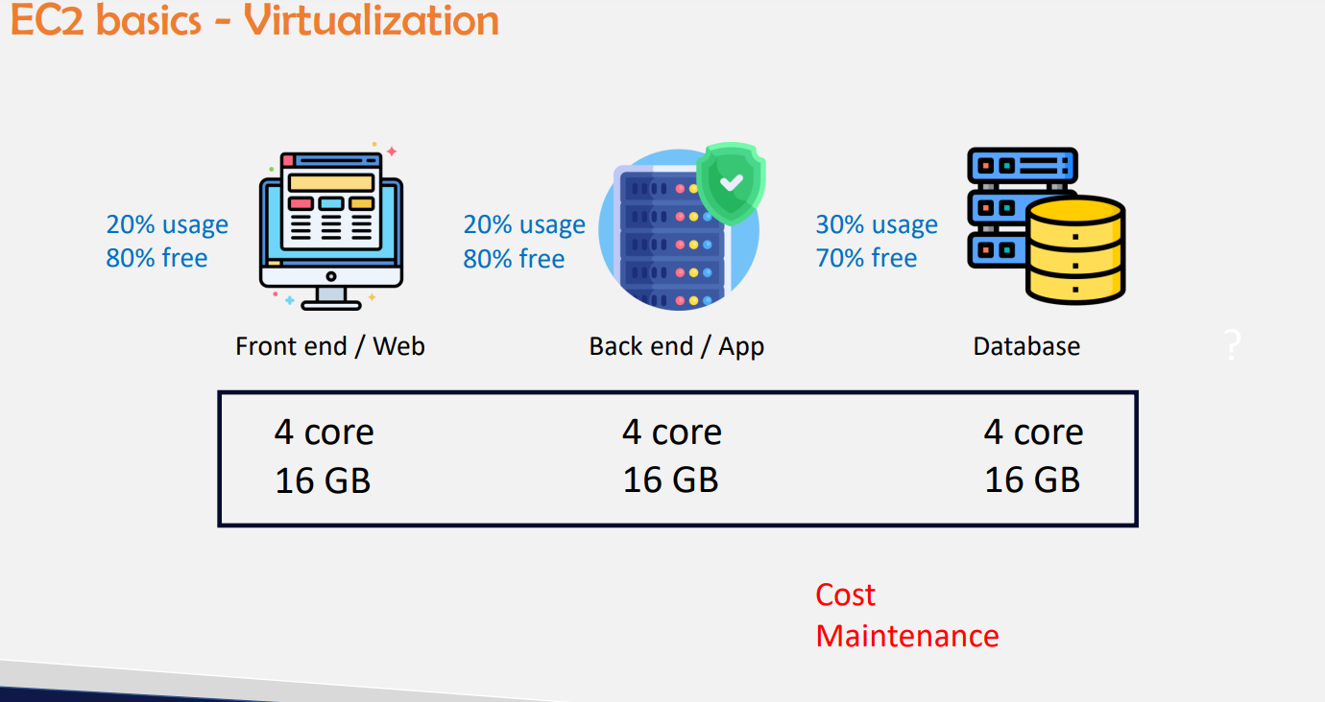

**Previously we need to mainitain cpu and Ram for each app i.e, Front end we need to maintain separately**

* **For backend we need to maintain separate cpu & ram**
* **For Database we need to maintain separate core & Ram**

**So previously it will be wasted as we can see from above picture that we only utilize 20-30% out of 100% utilization**

* **Actual utilization will be less and wastage will be more**
* **So cost will be more & maintenance will be more in terms of power cables ,cooling systems**
* **Again operational engineers should maintain this**
* **Cost -Total cost of ownership(capex)**
* **Maintenance – operational expenditure (Opex)**

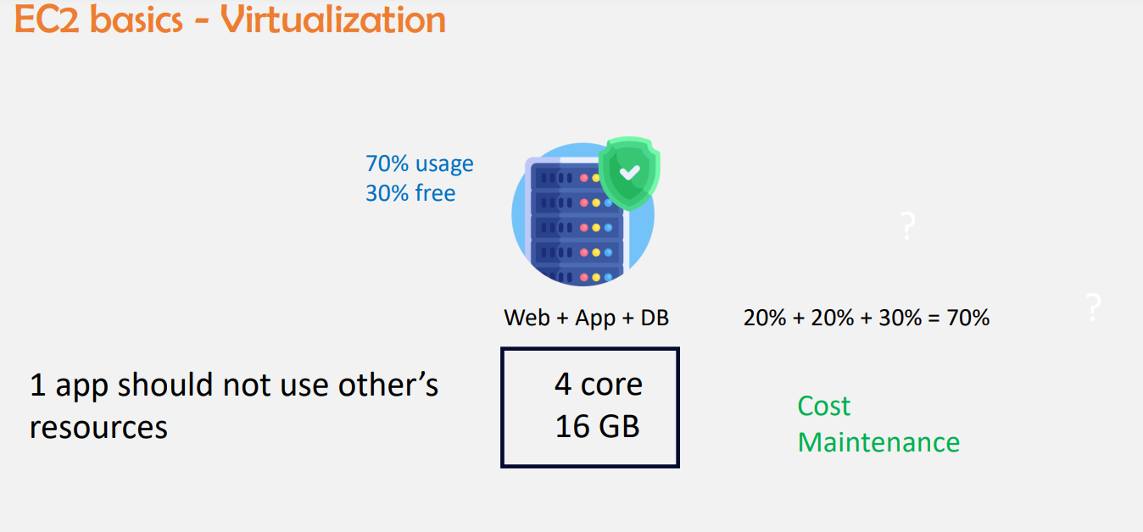

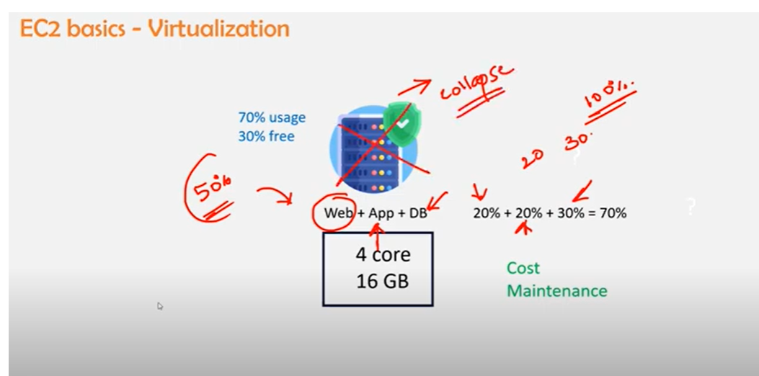

**If its placed in only one if web server is assigned only 20% but it consumed 50% of utilization that means that server might run slow to the users and it might be collapsed due to high utilization**

* **So what ever is assigned it should consume the same utilization <100%**
* **1 tier should not consume other tier utilization for example pubg if we have less storage in our phone and we download pubg mobile gets hanged as it consumes more utilization**

**No connection in between then**

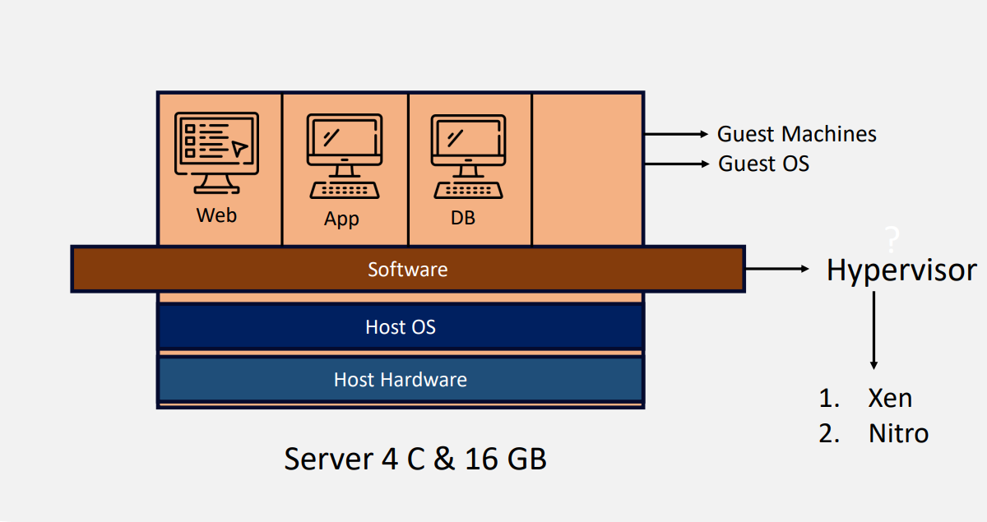

* **Physical servers**
* **Hypervisor is a software which allows 3 tier architecture to utilize only allotted cpu and ram**
* **It allows what you have allotted in Host os i.e in host os if you specify web should utilize only 1c1G Hypervisor duty is that it wont exceeds what ever is mentioned in Host OS**
* **Xen hypervisor is a open source hypervisor and it’s a 3rd party tool**
* **Nitro hypervisor is aws own hypervisor created by aws for high efficiency and performance**
* [**https://www.brendangregg.com/blog/2017-11-29/aws-ec2-virtualization-2017.html**](https://www.brendangregg.com/blog/2017-11-29/aws-ec2-virtualization-2017.html) **link for hypervisors**

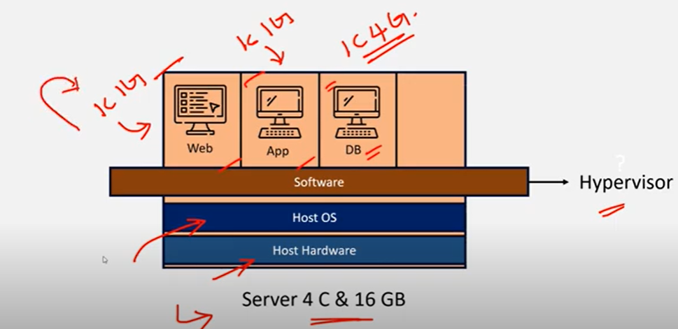

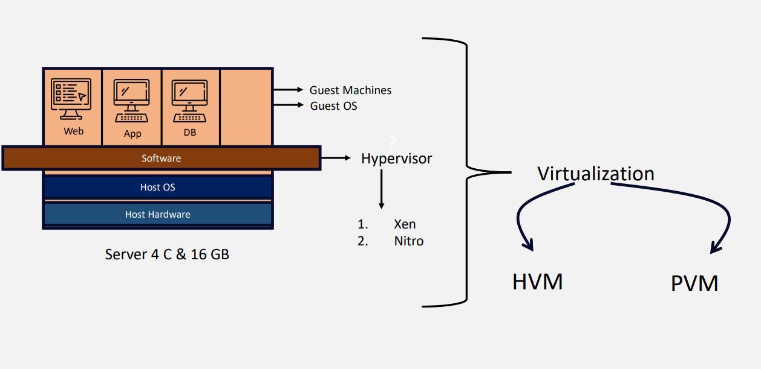

**SR-IOV**

**Hardware Virtualization: 100% virtualization and high performance when compare to PVM**

**Para virtualization**

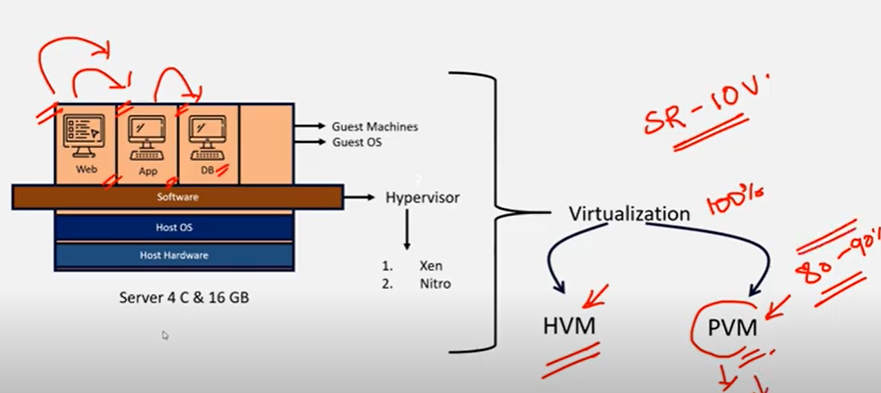

**In para virtualization 80-90% of the virtualization takes place becz from one tier to another tier it connects**

**So complete virtualization doesnot takes place**

* **NOW PVM is not using by aws as its giving less performance**
* **SR-IOV(Single route input ouput virtualization) for embedded machines we use this type of virtualization**
* **EC2: Virtualized machine after virtualization**
* **Baremetal : without virtualization physical server is called baremetal**
* **On ec2 if you perform virtualization it wont give much performance as it’s already virtualized**
* **On baremetal you can perform virtualization**
* **AWS +VMWARE (3rd party)**
* **Vmware is virtualisation software**
* **Vmware taked baremetal and his own hypervisor and makes it virtualized**
* **Ec2 previously are two types**

1. **EC2 classic (without vpc you can create servers) but now it has been removed from aws**
2. **Ec2 vpc**

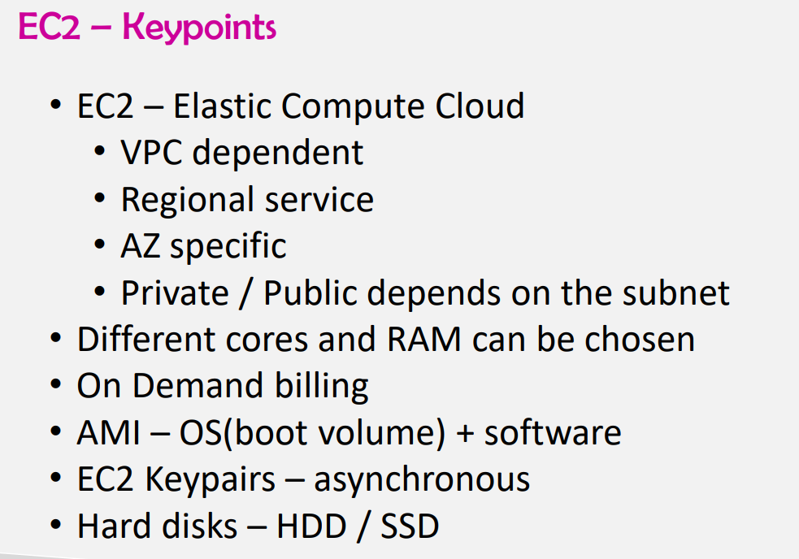

**If you create servers in public subnet then it is public server or else its private server**

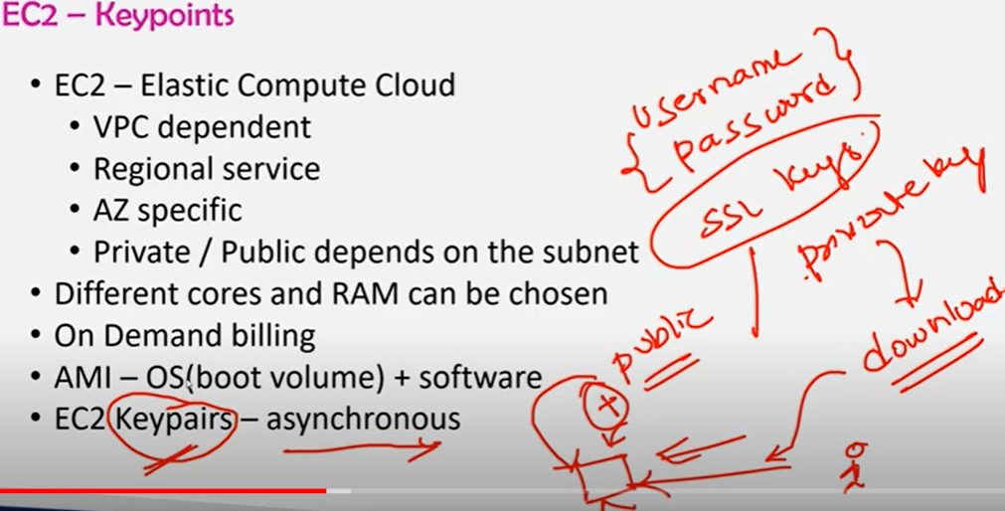

**Ec2 keypairs (synchronous key pairs is user name & pwd)**

**Asynchronous key pairs are SSL KEYS**

1. **SSL KEYS ARE OF 2 types**
2. **Public keys & private keys**

* **Private key while creating you need to download**
* **Public key will be stored in the server which u r creating then when you give private key to the server then you will get access to the server**
* **After creating server you can also change cpu ram**

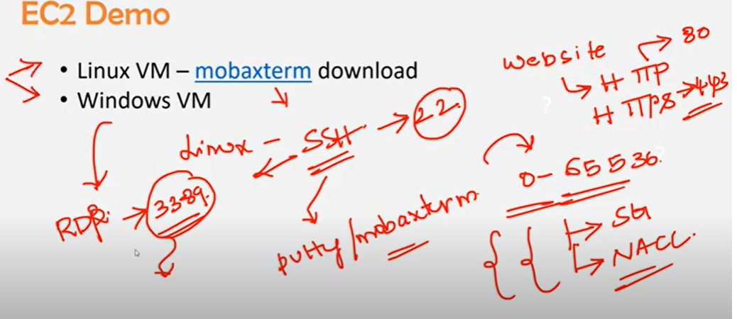

**For every website to get opened there will be https & http protocol**

**1)Http – portno 80**

**2)Https – port no 443**

**Linux machine to get runned on windows we need to have either putty/ mobaxterm**

**Linux protocol is SSH -port no 22**

**For windows RDP- 3389**

**This protocols need to be added in security groups if not it wont work**

**Ls-a list all files**

**Cd – change directory**

**Ls -list**

**Only putty uses ppk file rest use .pem**

**To create an EC2 instance steps**

**1)Instance Name**

**2)AMI (Amazon Machine Image)**

**3)Instance Type(cpu memory)**

**4)Keypair**

**5)Network settings(Vpc, subnets,Auto assign public ip ,security groups)**

**Security groups**

* **Security group name**

**Inbound security group**

* **Type, protocol,port range**
* **Source type source description**

**6)Configure storage**

If create you linux server in security group by defaultly ssh protocol wil be there and its port no 22

If create you linux server in security group by defaultly ssh protocol wil be there and its port no 22

* when you create server private keys will be there from downloads and public keys will be server
* Creating linux server(After creation )

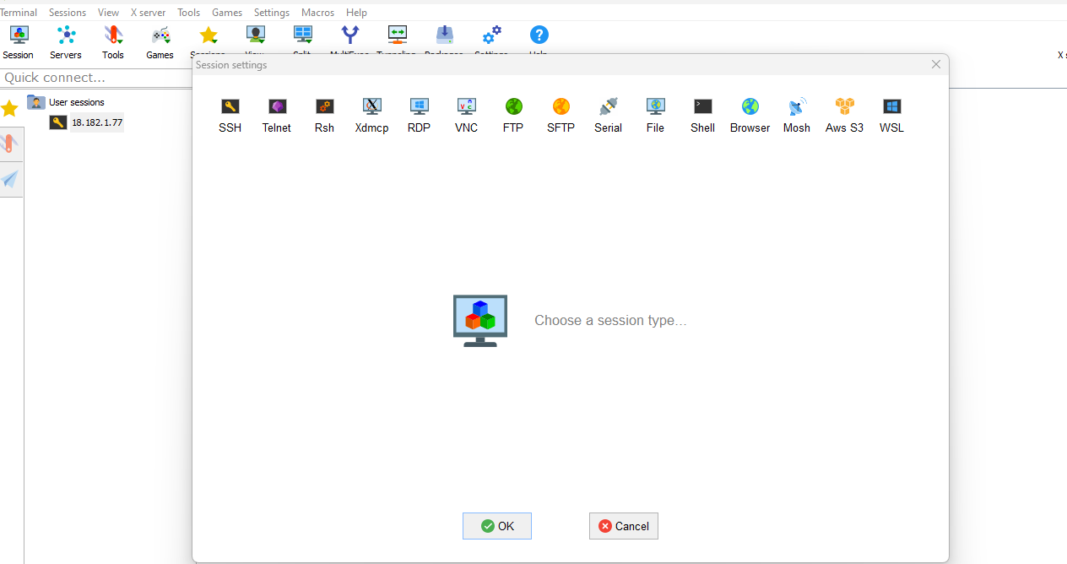

In mobaxterm application go to session and select SSH

* Remote host enter public ip address
* In advance setting private key select the file from the system which you have downloaded while creating the instance
* Linux server will be accessed and user name will be ec2-user

Then you can able to access

2nd method to connect linux server

* Select instance -> connect->select EC2 instance connect server directly gets connected in the browser
* This only gets opened when ssh (22 port is open )
* And public ip is enable

Ls -a (to list all files), cd.ssh (to go in to ssh folder)

Ls(list ) you will get access keys

Cat authorised key ( cat is to print) you will get public keys details)

PENDING TASK

1 . If you lost access keys( you need to same coonection through browser and create keys from open ssl or else you can create images for that particular instance (AMI) and you can create keys and use it

Windows server

* After creation of windows server click on connect select RDP client
* Upload private key and get pwd
* Update user id & pwd in remote desktop connection
* Your windows server gets connected
* For linux by defaultly 8 gb hdd will be provided
* For windows 30 Gb Hdd will be provided